Snake Body - base drawing document.

Segment length is 90 mm including Universal Joints. Est total snake length is 1060 mm being 10 x segments (900mm) plus head (60mm) and tail (100mm) pieces.

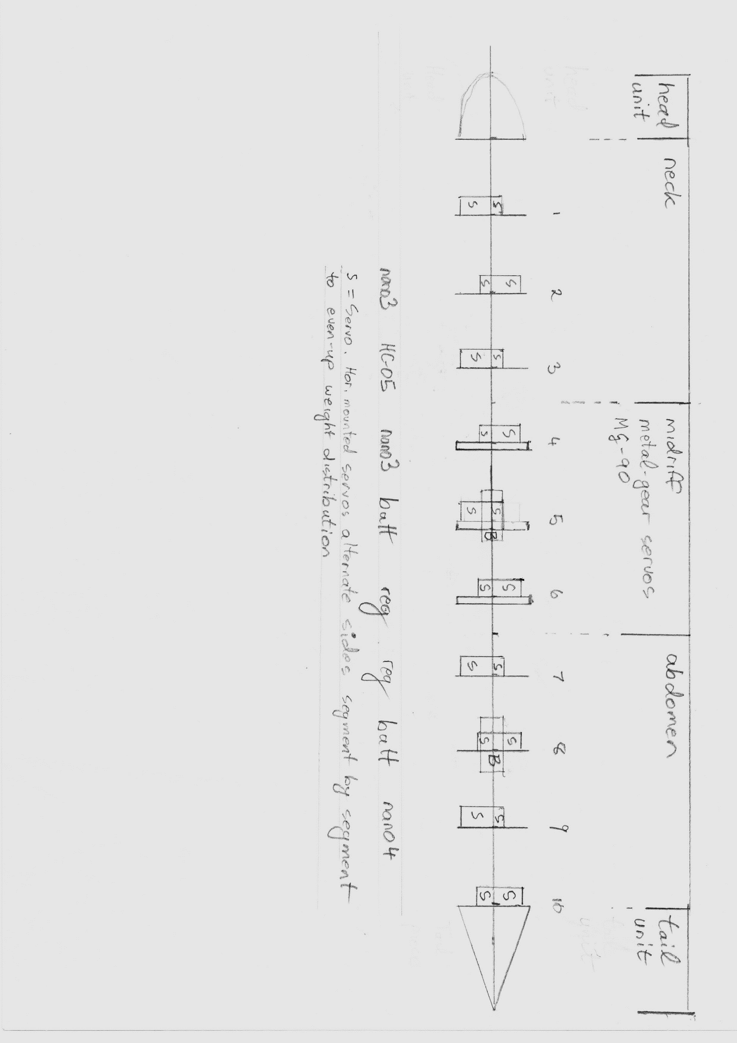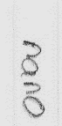

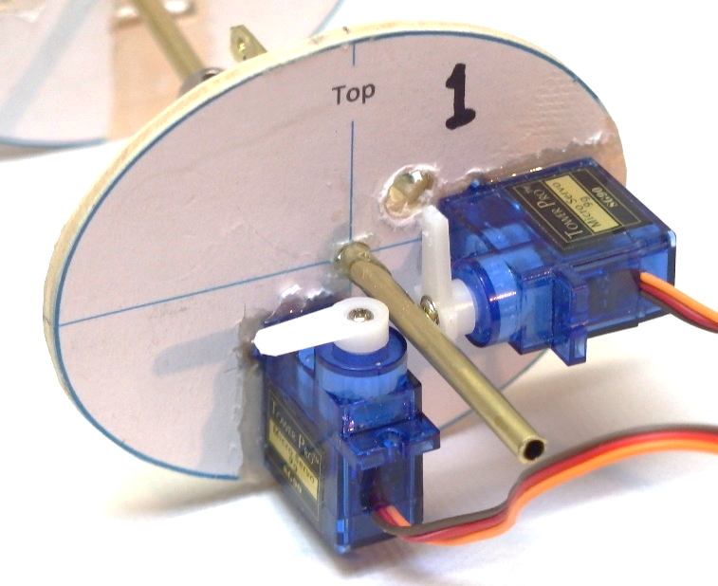S = Servo. Horizontally-mounted servos alternate sides segment by segment.  
 to even-up weight distribution.

B=Battery Wild Scorpion 2S - 7.4V nominal - 500mAH - mounted into segments 5 and 8.  
Segments 5 and 8 have vertically mounted servos in the top half of the "rib"  
leaving bottom half clear to mount the battery.  
Power supply to segments 1-5 is separate to and independent of   
power supply to segments 6-10

